dd00380_

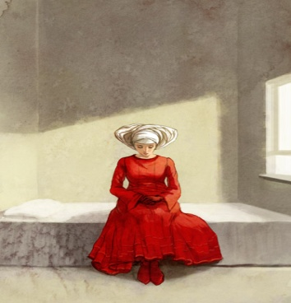Dystopia Project - Due Feb. 22nd

* Your assignment is to create a dystopia- a warning of dangers in the days to come. Project a currently outstanding social trend into the future. Not a human foible in the abstract, such as greed, but a social direction you feel may end unhappily. For example, think of social obsessions such as; The Christmas craze, faddism, dieting, physical fitness, pre-fab housing, sexual license, overpopulation, the waste of natural resources, pop art, supermarkets, church service trends, crime, texting, cell phones, the ever increasing vernacular, frivolous lawsuits, body art, just to name a few. What are you interested in writing about?
* Be entertaining. This is by no means synonymous with hilarity, but your story should be fascinating and should entice the reader with its images and implications. You must create a strong narrative which invites the reader along for the journey. You will need a fertile and well-controlled imagination.
* Adopt the voice of a historian situated in the future looking backward. Hence your story should be in the past tense. You must trace the trend in an entertaining yet accurate fashion up to this year, and then project it into the future.
* I encourage you to incorporate allusions to historical events or figures, literature, music, and any other concepts that will support and enhance your idea.
* If you plan to collapse your dystopia with a bang or a whimper, the catastrophe should develop from the destructive seeds within the trend itself, not from some external, unforeseen force.
* Your project should be about three pages in length. Use about a page to trace your trend up to today and then two pages to project it into the future. It must be typed, double spaced- and you should have a cover page with a title. Accompanying illustrations are optional, but must not detract from the length of the paper.

dd00380_

dd00380_

Handmaid’s Tale ~ Alternative Assignment

If you have written a Dystopia before, or for some reason you do not feel sufficiently negative, you may do the following:

Task- At the 12th Symposium on Gileadean Studies, Professor Piexoto was able to announce that a time capsule containing much more than tape cassettes, memoirs and a diary had been found in the former Republic of Gilead.

Prepare items for the time capsule to show what you think life was like in Gilead, basing your ideas on evidence from the novel.

* A news report on the war.
* A wanted poster for an escaped Handmaid.
* An update of Serena Joy’s Newsweek profile.
* Offred and Ofglen’s shopping lists.
* A photograph of a ‘family’, with an explanation of its composition.
* A letter from a Commander’s wife to Serena Joy including, for example, an invitation to a ‘Birth Day.’
* An entry form Offred’s secret diary.
* An entry from Nick’s secret diary, for example, when he winked at Offred or touched her foot.
* A Japanese travel brochure’s description of Gilead.
* A news report on a ‘Salvaging.’
* An entry from the Commander’s journal, recounting Offred’s first visit to his study.
* A news report of a ‘Women’s Prayvaganza’ organized to celebrate a group wedding.

• Your project should be about three pages in length. It must be typed, double spaced- and you should have a cover page with a title. Accompanying illustrations are optional, but must not detract from the length of the paper.